**1. Name of the Students: -**

1) Saloni Bajrang Kamble.

**5. Proposed Title: -** ATM Banking System

**6. Abstract :-**

* In the growing technological world, people want their work to be very simple in order to save their time. As we know some new technology is becoming popular in banking sector, which is referred as ATMs. It makes the work of people as well as the banking sectors to be easy. ATMs help in providing money to the people nearer to the living area by saving their time so that it becoming very popular.
* ATM BANKING SYSTEM:
* The ATM BANKING SYSTEM is the project which is used to access their bank accounts in order to make cash withdrawals. Whenever the user need to make cash withdrawals they can enter their PIN number (personal identification number) and it will display the amount to be withdrawn in the form of 500’s, 1000’s and 2000’s. once their withdrawn was successful, the amount will be debited in their account.

**7.** **Introduction: -**

* ATM (Automated Teller Machine) or a cash point is a computerized machine.
* ATMs plays a vital role in facilitating the banking services to banks as well as customers.
* ATM is the back bone of retail banking sector.

Automated Teller Machine is a computerized that provides the customers of banks the facility of accessing their accounts for dispensing cash and to carry out other financial transactions without the need of actually visiting a bank branch.

Services available through an ATM includes :

* Make deposits of cash and checks.
* Withdraw cash.
* Transfer money between accounts.

Obtain account balance.

**8.** **Objectives: -**

* Our main objective is to speed up the transactions done by customers. No manual transactions needed generally.
* The second objective is to save the time which is very important now a days.

It will include other objectives such as :

* To render accurate services to customer.
* The reduction of fraudulent activities.
* To achieve speedy processing of customer data.
* To reduce error processing, the guarantee of increase security.

**9.** **Proposed** **work: -**

The system customer transactions, satisfies the requirements of the existing system in full-fledged manner. Through this system, customer can make fast transaction and view the last transactions easily

For the Bank :-

Increasing existing business .

For the Customer :-

Save time and money.

It can get cash whenever and wherever required.

**10. Architecture: -**

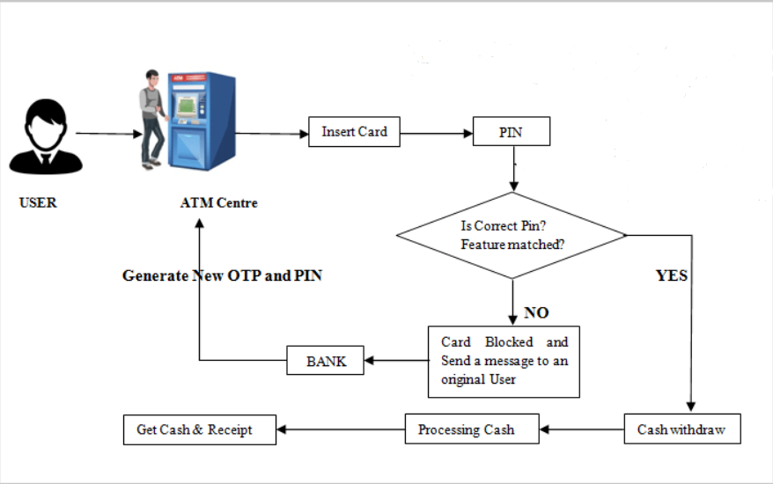

**11. Implementation steps: -**

1. Start
2. Insert credit / Debit card
3. Is card valid ?
4. Insert pin code
5. Hold the card
6. Choose action

a) Withdraw money

b) Account balance

c) Deposit amount

d) Exit

1. Choose the amount of money to withdraw
2. Show account balance
3. Deposit amount
4. Sufficient fund in the account
5. Release money
6. End

**12. Future** **Scope: -**

* Using an ATM, customers can access their bank deposit or credit accounts in order to make a variety of financial transaction.
* Most notably cash withdrawals and balance checking, as well as transferring credit to and form mobile phones.
* ATMs can also be used to withdraw cash in a foreign country.

**11.1.** **Flow Chart Diagram –**

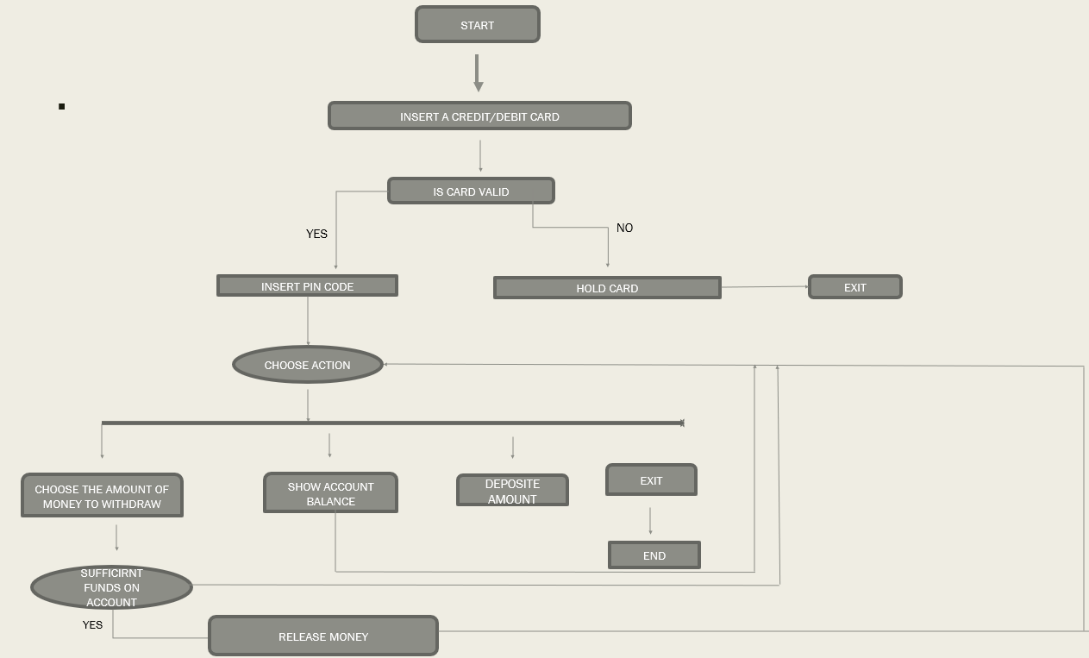

**12.** **Requirements: -**

* **Languages**

C++

**Hardware Requirement** **:**

* Ram – 4 GB Ram
* Processor – intel core i5

**Software Requirement :**

* Operating system – Windows 10
* Internet connection
* Dev c++

**13. References: -**

* [**www.google.com**](http://www.google.com/)
* [**www.codewithc.com**](http://www.codewithc.com/)
* [**www.pptsearch.net**](http://www.pptsearch.net/)
* [**www.slidescarnival.com**](http://www.slidescarnival.com/)

**Date:20-02-2022**

**Name of Student Signature**

1) Saloni Bajrang Kamble

**Thank you.**